**DAILY ONLINE ACTIVITIES SUMMARY**

|  |  |  |  |  |  |  |  |
| --- | --- | --- | --- | --- | --- | --- | --- |
| **Date:** | **17/06/2020** | | | | **Name:** | **Syed Rabeya Aamir** | |
| **Sem & Sec** | **8th B** | | | | **USN:** | **4AL16CS112** | |
| Online Test Summary | | | | | | | |
| **Subject** | | **--** | | | | | |
| **Max. Marks** | | **--** | | **Score** | | **--** | |
| Certification Course Summary | | | | | | | |
| **Course** | **ADVANCED ANALYTICS WITH AMAZON SAGEMAKER.** | | | | | | |
| **Certificate Provider** | | | **Aws** | **Duration** | | | **6 hrs** |
| Coding Challenges | | | | | | | |
| **Problem Statement:**  **1) Python Program to find largest element in an array.** | | | | | | | |
| **Status: Solved** | | | | | | | |
| **Uploaded the report in Github** | | | | **YES** | | | |
| **If yes Repository name** | | | | **rabeya** | | | |
| **Uploaded the report in slack** | | | | **YES** | | | |

**Certification Course Details:**



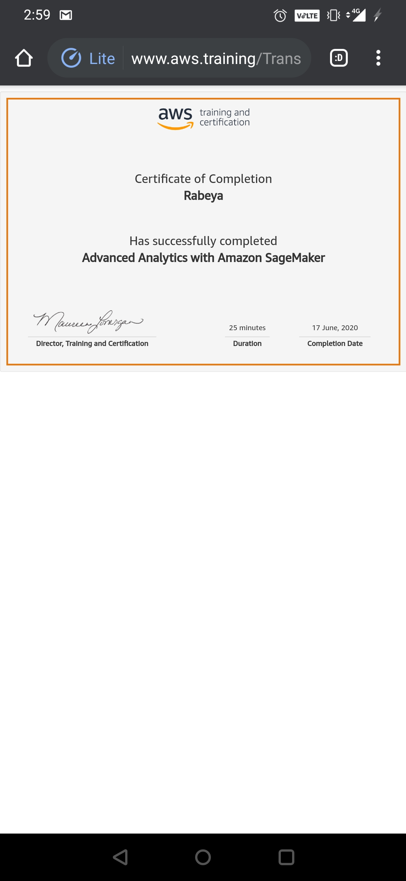

# CODE:

Program no:1

# Python Program to find largest element in an array.

def largest(arr,n):

# Initialize maximum element

max = arr[0]

for i in range(1, n):

if arr[i] > max:

max = arr[i]

return max

arr = [10, 324, 45, 90, 9808]

n = len(arr)

Ans = largest(arr,n)

print ("Largest in given array is",Ans)